[**https://handsonreact.com/docs/labs/ts/StylesUsingCSS**](https://handsonreact.com/docs/labs/ts/StylesUsingCSS)

**Lab 3: Styles Using CSS**

**Objectives**[**​**](https://handsonreact.com/docs/labs/ts/StylesUsingCSS#objectives)

* Install CSS
* Apply CSS

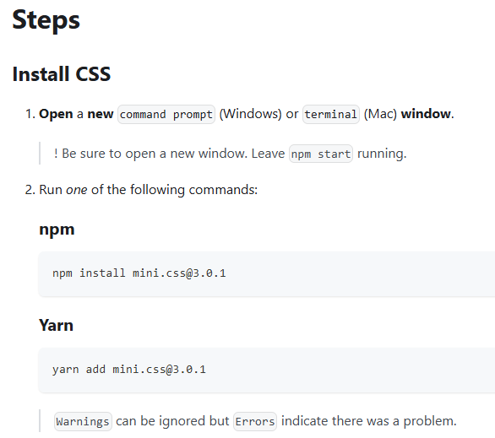

* + npm install [mini.css@3.0.1](mailto:mini.css@3.0.1)

C:\Users\Family\git\keeptrack> npm install [mini.css@3.0.1](mailto:mini.css@3.0.1)  
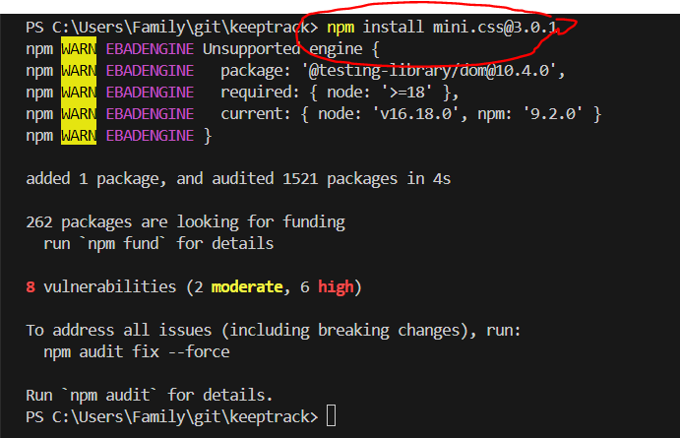

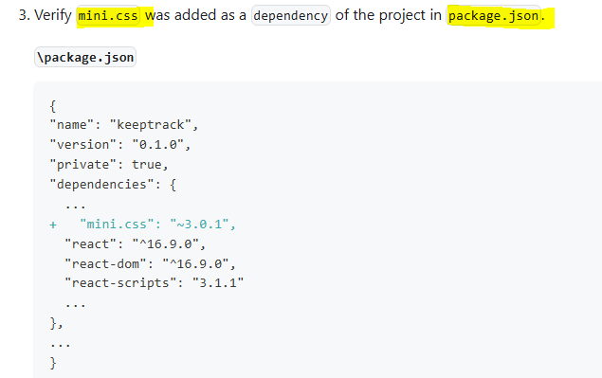

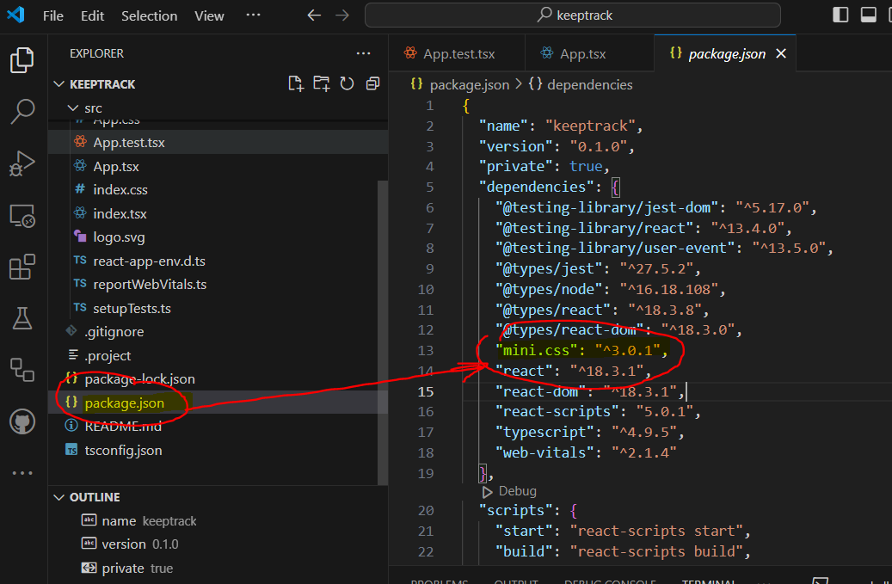

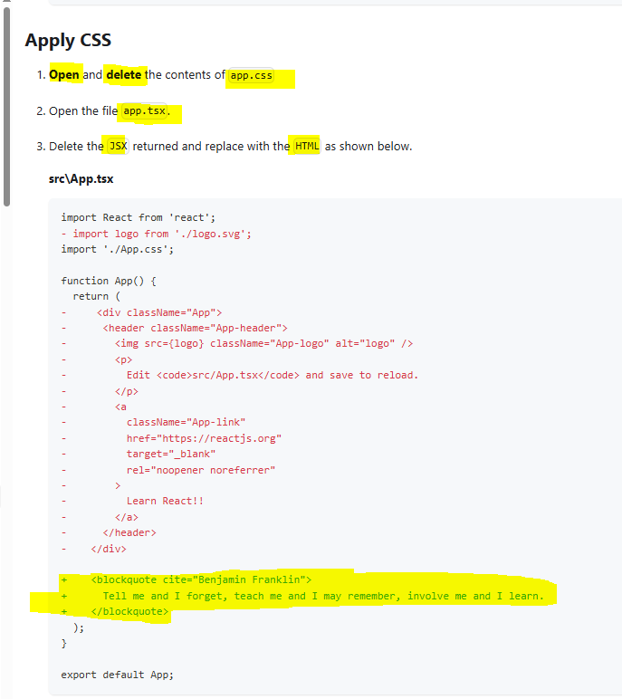

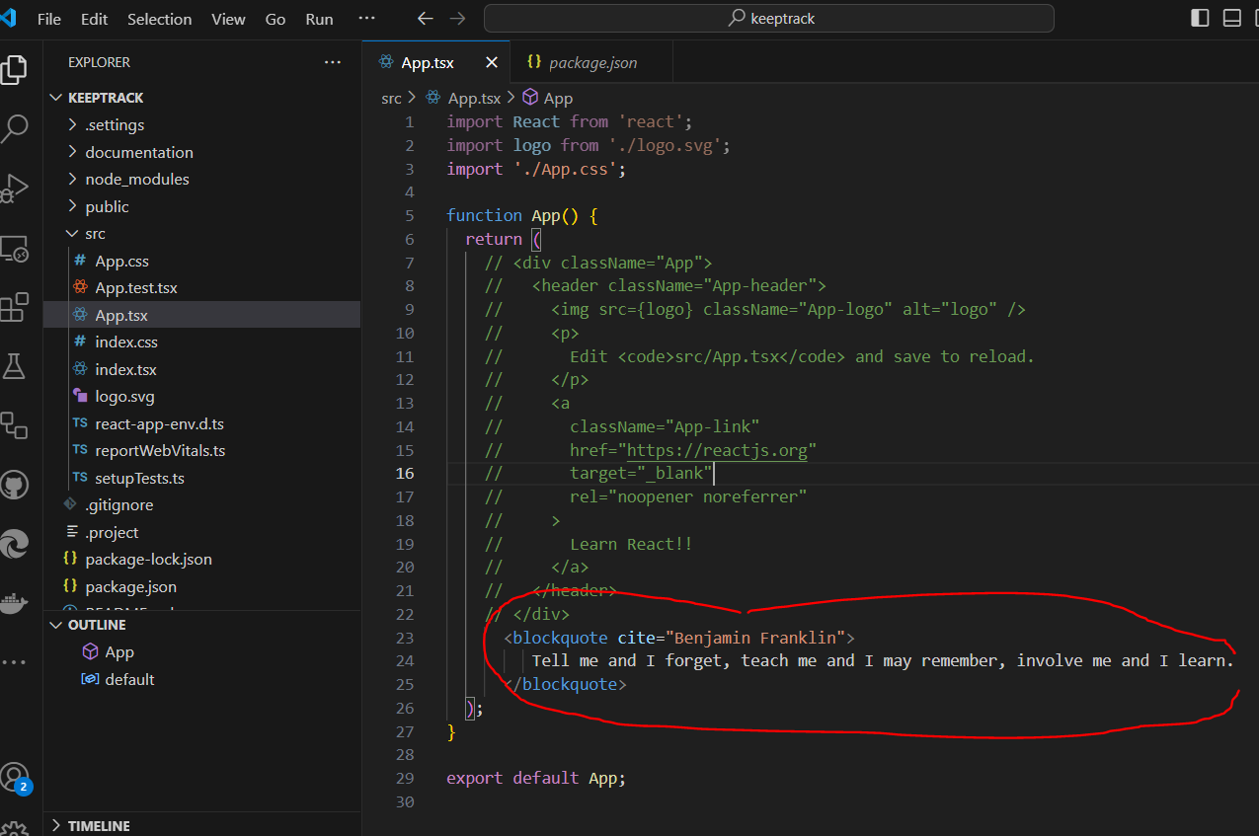

src/App.tsx

import React from 'react';

import logo from './logo.svg';

import './App.css';

function App() {

  return (

    // <div className="App">

    //   <header className="App-header">

    //     <img src={logo} className="App-logo" alt="logo" />

    //     <p>

    //       Edit <code>src/App.tsx</code> and save to reload.

    //     </p>

    //     <a

    //       className="App-link"

    //       href="https://reactjs.org"

    //       target="_blank"

    //       rel="noopener noreferrer"

    //     >

    //       Learn React!!

    //     </a>

    //   </header>

    // </div>

      <blockquote cite="Benjamin Franklin">

         Tell me and I forget, teach me and I may remember, involve me and I learn.

      </blockquote>

  );

}

export default App;

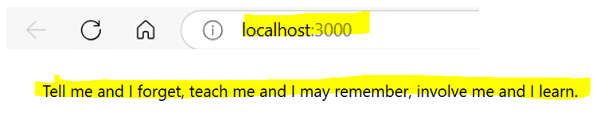

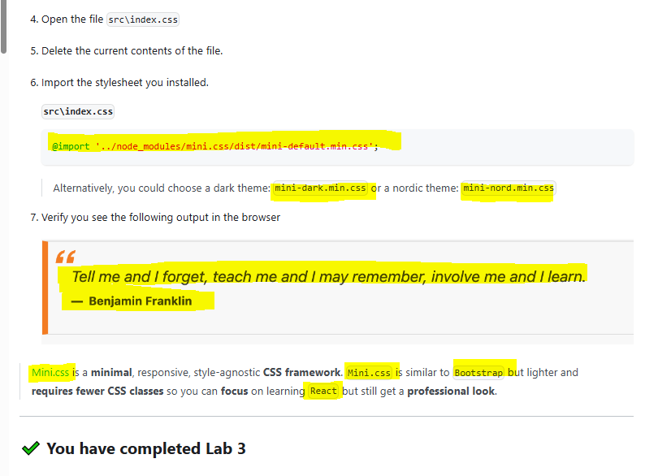

* + **@import '../node_modules/mini.css/dist/mini-default.min.css';**

@import '../node_modules/mini.css/dist/mini-default.min.css';

